lanthanide
select indium;color purple;select sodium;color grey

hide sodiums;polyhedra bonds (connected (indiums));spacefill 0.2
polyhedra bonds (connected (nitrogens));spacefill 0.2;hide bonds

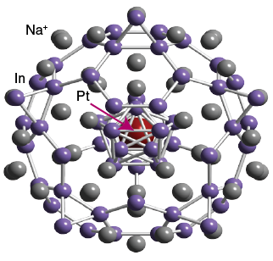
Click to display Platinum cages

is an example of a Zintl phase compound, formed by the reaction of an alkali metal (sodium) with a p block element (Indium.) The complex structure of
consists of fulleride like networks (formed from Indium atoms), encasing the Platinum atoms at the centre.

hide atomno<100,sodiums

hide @102,@104,@103,@105,@107,@109,@108,@104,@106,@111,@110,@101,@100

hide atomno<100,sodiums;delete @102,@104,@103,@105,@107,@109,@108,@104,@106,@111,@110,@101,@100;moveto { 489 -822 -292 22.07}

